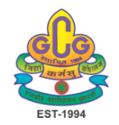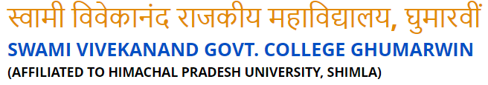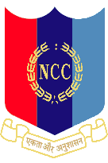

Activity Report: Azadi Ka Amrit Mahotasava
On the occasion of celebration of Azadi Ka Amrit Mahotasava, following activities were carried out by NCC troop of G.C. Ghumarwin:
- Participation in Tiranga Rally in Kallari and Delag areas of Ghumarwin.
- Independence Day Parade and flag hoisting
- Participation in Poster Making, Declamation contest etc organised by college
- Tree plantation by the cadets
Photographs of the events are:
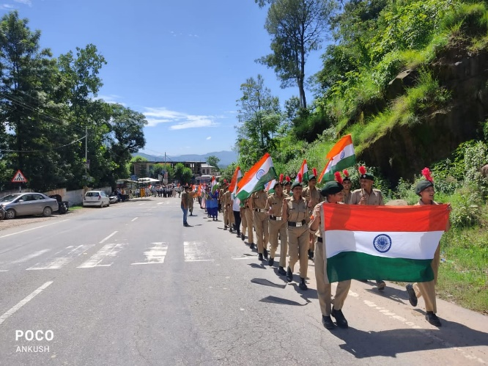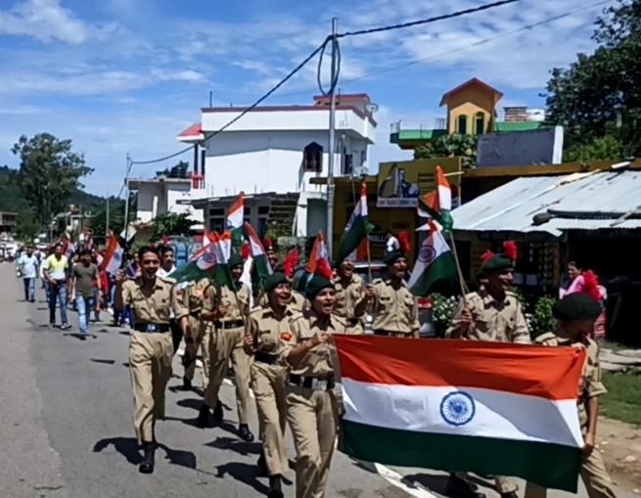

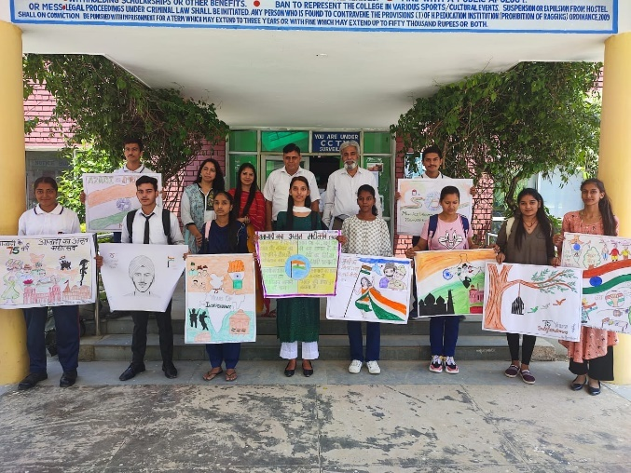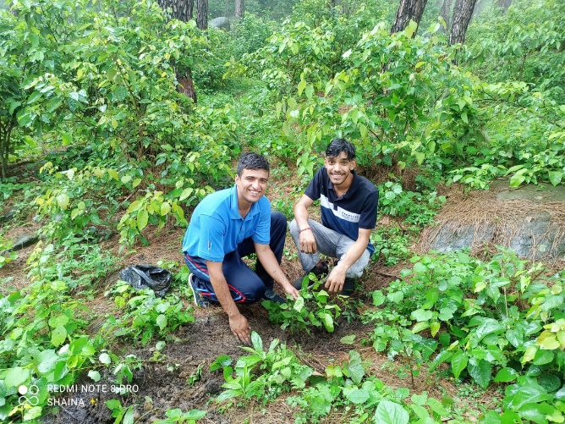
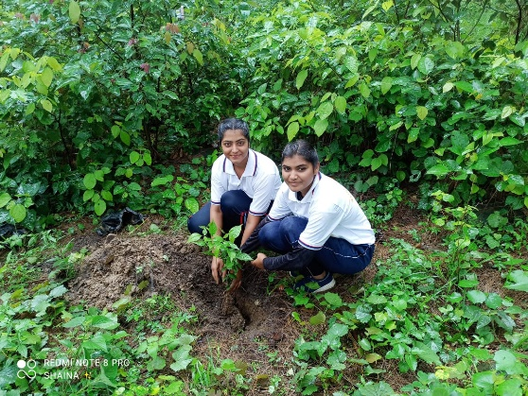

21-12-2022
Activity Report:Blood Donation Camp

The college organised a Blood donation camp on December 21, 2022 in the campus. This camp was jointly organised by Health Club, NCC, NSS and Scouts and Guides units of the college. Total 30 units of blood was donated by NCC cadets, students, teachers and other volunteers. Principal Prof. Ram Krishan appreciated all the donors and also the participating units of the college for this noble cause.
